**Authors : ALOWONOU Kowovi Comivi**

**Demba COUTA**

**Humidity and temperature control with arduino**

Contents

**I.** **PROJECT DESCRIPTION** 2

**II.** **Hardware** 2

# **PROJECT DESCRIPTION**

The project's goal is to protect objects such as archeological objects, contained in a room, keeping them within a range of temperature and humidity to prevent their degradation.  
For this, a data acquisition system will be established (temperature and humidity sensor) to detect the humidity and the temperature of the room.  
If the temperature or humidity of the room reaches a certain maximum or minimum threshold then an alarm is triggered and a message is sent to the room manager. It will also be possible to follow the evolution of the temperature and humidity of the room through a web application.

# **Hardware**

1. Temperature sensor NTC

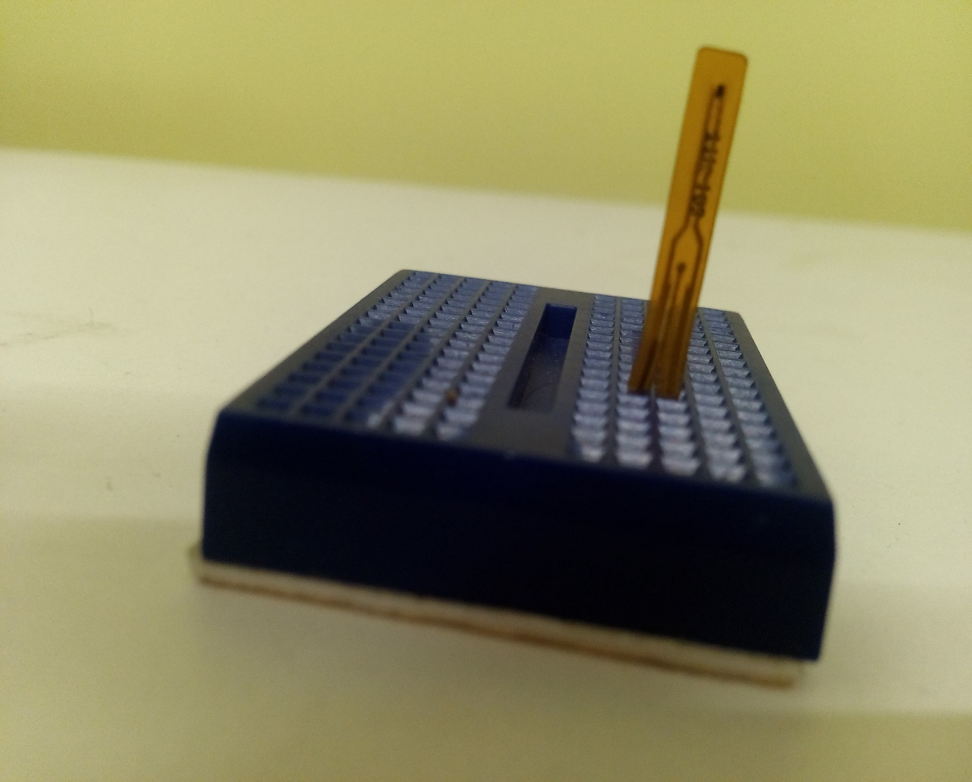

1. Humidity sensor

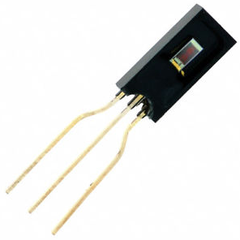

1. Piezo buzzer

